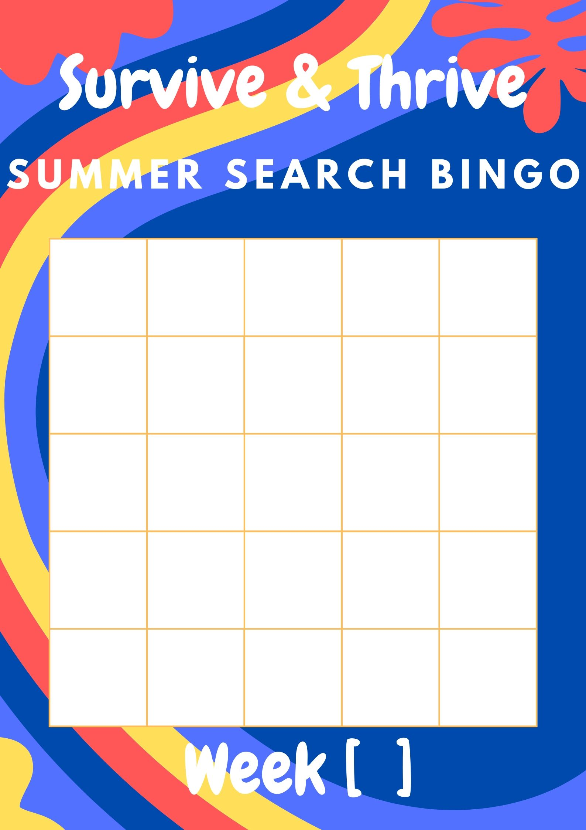

Ask for Help

Take a Nap

Compliment Someone

Try a Pinterest / YouTube Tutorial

Color or Paint

Help Someone

Stretch

Cry, Scream, or Laugh
1

Thank Someone

Try Meditation

FREE SPACE
WASH YOUR HANDS

Call a Family Member

Drink Water

Listen to a Podcast

Talk to Your Mentor

Video Chat a Friend

Dance

Journal or Write

Make a
TikTok

Watch Something Funny

Play a Game

Draw

Hug Yourself

Go Outside (safely)

Bake or Cook

